Q1.
A conversion graph for speeds is shown.
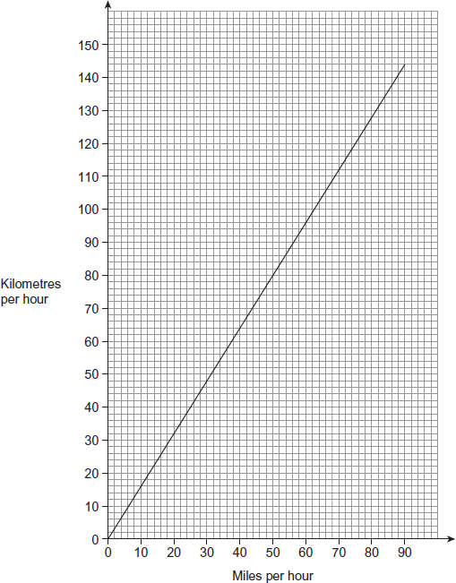
(a) In France the motorway speed limit is 130 kilometres per hour.
In the UK the motorway speed limit is 70 miles per hour.
In which country is the motorway speed limit higher?
You must show your working, which may be on the graph.
............................................................................................
............................................................................................
Answer ......................................................................
(1)
(b) Tom is on holiday in France.
He leaves Calais at 10.45 am
The distance from Calais to Paris is 288 kilometres.
He says,
“If I drive at an average speed of 60 miles per hour I will be in Paris before 2 pm”
Is he correct?
You must show your working.
............................................................................................
............................................................................................
............................................................................................
............................................................................................
............................................................................................
............................................................................................
(4)

Q3. Conversion graph for dollars and pounds
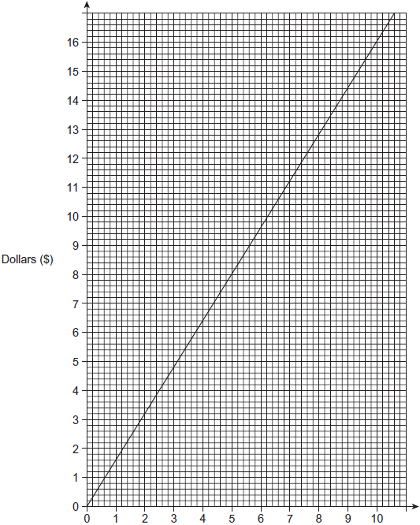
Pounds (£)
(a) Use the graph to convert £5 into dollars ($).
Answer $ ...................................................................
(1)

(b) Lucy is going to the USA on holiday.
She converts £500 into dollars ($) at the rate shown by the graph.
How much does she get in dollars ($)?
............................................................................................
............................................................................................
............................................................................................
Answer $ ...................................................................
(2)

(c) After the holiday the exchange rate is £1 = $1.75
She converts $150 back into pounds (£).
How much does she get back?
............................................................................................
............................................................................................
............................................................................................
Answer £ ...................................................................
(3)
(Total 6 marks)
Q4. (a)
 | Miles | 0 | 20 | 40
 | Kilometres | 0 | 32 | 64

Draw the conversion graph for miles and kilometres.
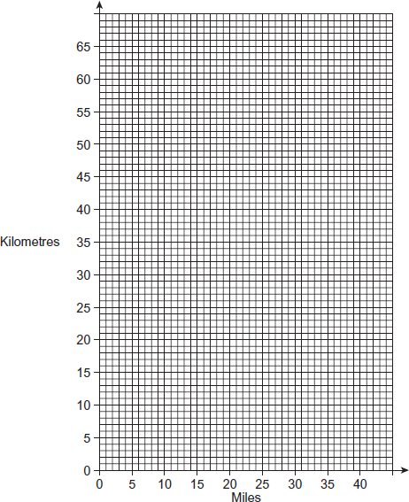
(2)

(b) Convert 35 miles to kilometres.
Answer ................................................................ km
(1)

(c) Convert 24 kilometres to miles.
Answer ............................................................. miles
(1)
(Total 4 marks)

Q5. The graph shows the total pay (£), that Fatima receives for up to 35 hours worked.
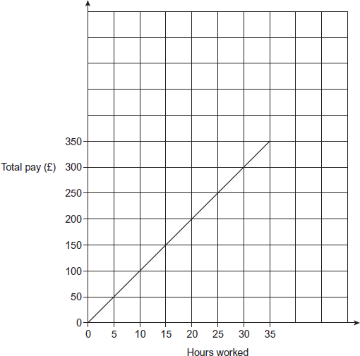

(a) How much is her total pay if she works for 35 hours?
£ ................................................................................
(1)

(b) How much is she paid per hour?
............................................................................................
£ ................................................................................
(1)

(c) She is paid £ 20 per hour for each hour she works above 35 hours.
Continue the graph for up to 45 hours worked.
You must complete the scales on the axes.
............................................................................................
............................................................................................
............................................................................................
(4)
(Total 6 marks)

Q6.The graph shows the cost of gas from GasCo. £C is the cost of the gas and n is the number of units of gas used.
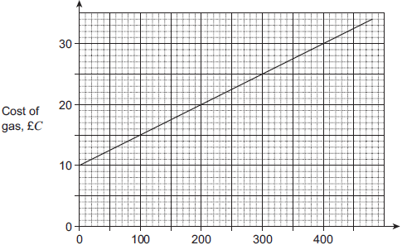
Units of gas, n
Use the graph to obtain a formula for C in terms of n.
.....................................................................................................
.....................................................................................................
.....................................................................................................
.....................................................................................................
.....................................................................................................
.....................................................................................................
Answer ......................................................................
(Total 3 marks)
Q7.Tyre pressure for bicycles is measured in pounds per square inch (PSI) or Bars. Here is a conversion graph for PSI and Bars.
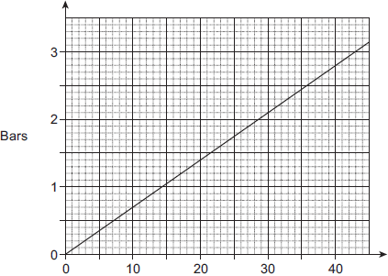
PSI
(a) Use the graph to convert 40 PSI to Bars.
............................................................................................
Answer ............................................................. Bars
(1)
(b) The tyre pressure for a racing bicycle is 100 PSI.
Work out this pressure in Bars.
You must show your working.
............................................................................................
............................................................................................
Answer ............................................................. Bars
(3)

