Hey lovelies! Hopefully some of this is still familiar! If not, just do your best, start with the green, move on to amber then red if you can. Zoom in on each bit and type your answers in the spaces. And remember, BBC Bitesize is your best friend!

Label the parts of the heart: A - B - C - D - E - F - G - H - I - J -

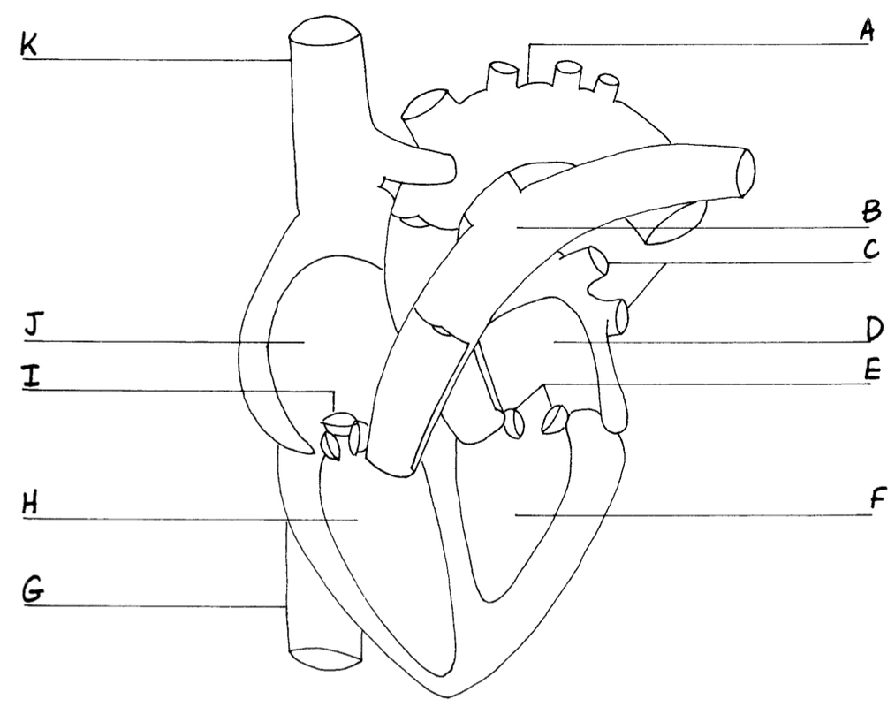

Explain why enzymes will not work in high temperatures and extremes of pH. You must discuss the ‘Lock & Key’ hypothesis of enzyme action in your answer.

Use the diagram opposite to describe the ‘Lock & Key’ hypothesis for enzyme action. Make sure you use all the words on the diagram in your explanation.

What are statins?

What are stents?

What is a pacemaker?

**Unit: Organisation**

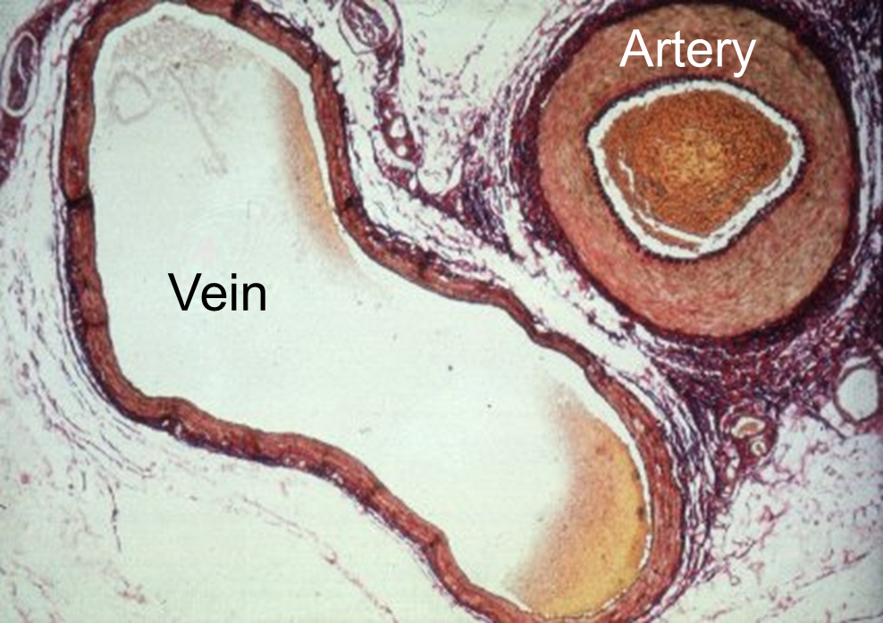

Describe three differences between the two blood vessels pictured opposite.

1.

2.

Describe what happens in coronary heart disease.

What can lead to this happening?

Name 3 factors that can increase the risk of heart disease: 1. 2. 3.

Name the four components of blood: 1. 2. 3. 4.

Put the five levels of organisation found in multicellular organisms into an order of increasing size and complexity in the spaces below: Tissue, organism, cell, organ system, organ

Label the parts of the Digestive System listed: 1 - M 2 - O 3 - S 4 - S I 5 - L I 6 - A 7 - R 8 - G B 10 - L Add 2 extra labels to the diagram to show the location of the Salivary glands and the pancreas.

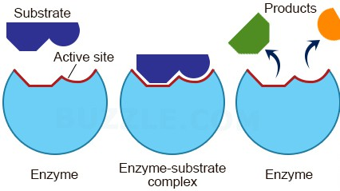

Describe the functions of the 5 organs of the Digestive System listed below:

|  |  |
| --- | --- |
| **Digestive System Part** | **Function** |
| Stomach |  |
| Small Intestine |  |
| Large Intestine |  |
| Salivary Glands |  |
| Pancreas |  |

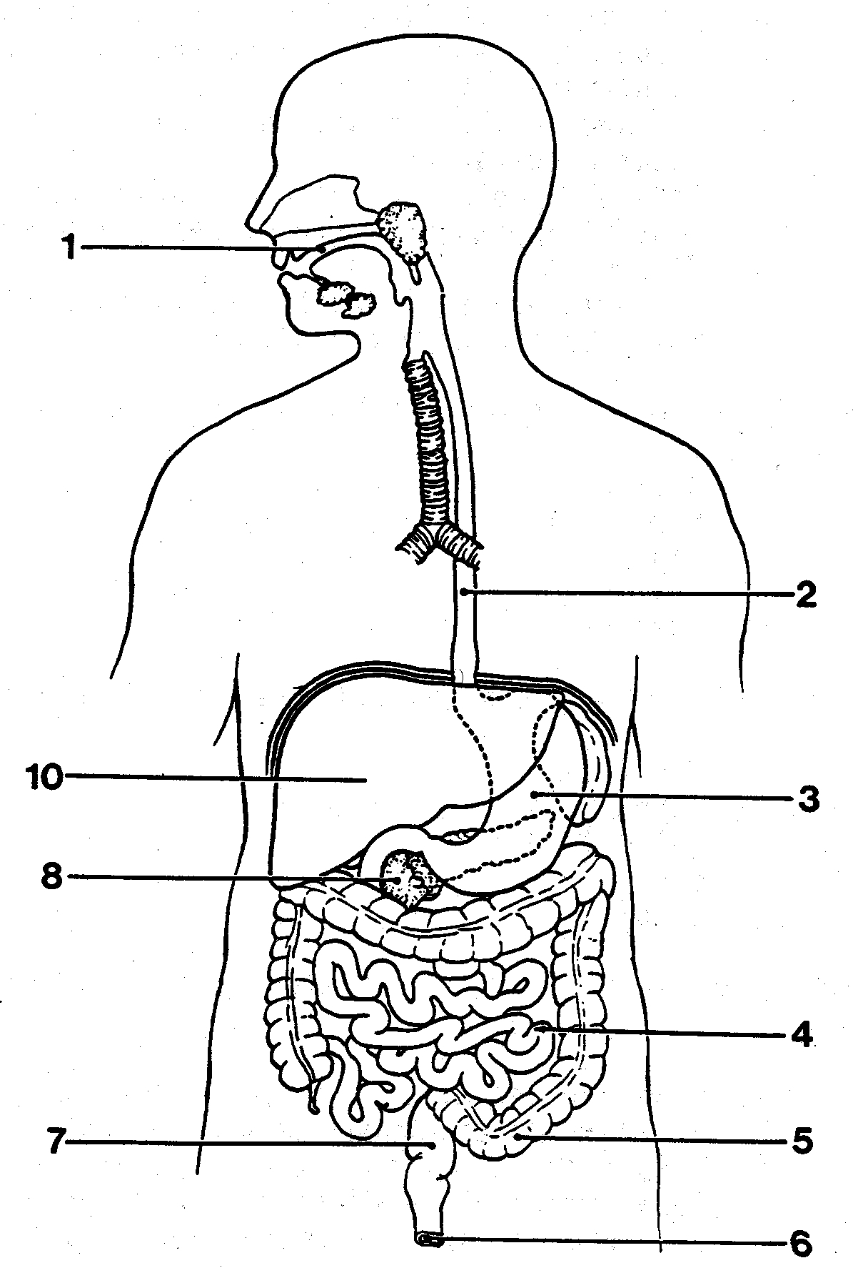

For each of the five levels of organisation found in multicellular organisms give both a description of the level and an example. The first answer has been completed for you …

|  |  |  |
| --- | --- | --- |
| **Level of Organisation** | **Definition** | **Example** |
| Cell | Basic building blocks of all living organisms | Muscle Cell |
|  |  |  |
|  |  |  |
|  |  |  |
|  |  |  |