The strongest form of a gene which always shows itself in the offspring. Dominant alleles are represented by a capital letter. E.g. B represents the brown eye gene.

Dominant:

Phenotype:

How the gene expresses itself (the characteristic of the offspring).

Tasks

1, Complete a cross for Homozygous brown eyed mum and a dad with blue eyes. I have completed the first combination for you.

2, What are the chances that the children will have blue eyes?

We can work out all the possible combinations if we know the genotype of the parents using a punnet square diagram [Click here to watch video](https://www.youtube.com/watch?v=prkHKjfUmMs)

The weaker form of a gene which is overpowered by the dominant. Recessive alleles are represented by a lower case letter. Eg b represents the blue eye version of the gene.

Recessive:

3,

* How many Homozygous pairs are there?
* How many Heterozygous pairs are there?
* Are the Homozygous pairs recessive, dominant or both?
* What is the phenotype of the children?
* What is the genotype of the children?

Dad: bb

b

b

B

bB

B

Mum: BB

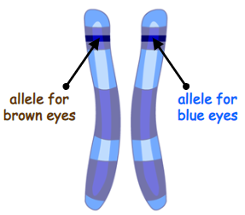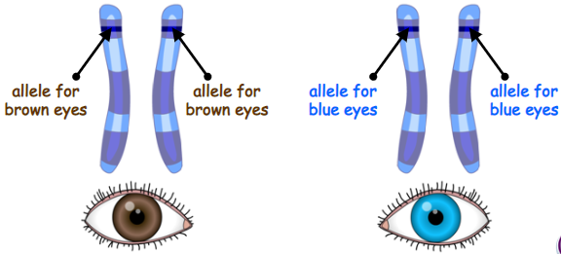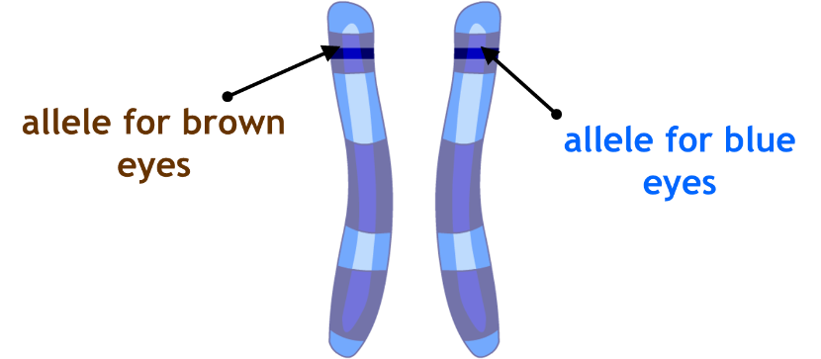

The type of alleles that make up a gene.

Genotype:

Allele: Different forms of the same gene.

(Each person inherits two alleles for each gene, one allele from each parent. These alleles may be the same or may be different from one another).

Words I need to know

Remember, we inherit our characteristics, on genes we get from our parents. We are going to look at this in more detail. Recall from cell biology that genes are sections of DNA and that DNA is found coiled into chromosomes in the nucleus of a cell.

Heterozygous

If the alleles are different, we call them…

Homozygous

If the alleles are the same we call them….

chromosome from mother

chromosome from father