Hey guys, I think you’ll find this interesting! You may need to have your definitions from the inheritance worksheet to hand to refresh your memory.

Inherited disorders are caused by mutations - which is a change in a gene or a chromosome. It can cause a change in a characteristic.

e.g. albinos – the gene for pigment changes, and melanin cannot be made so skin and hair/fur are pale and eyes appear red in colour.

Gene mutations are fortunately usually recessive (Use small letter c to represent this) and can be hidden by a dominant allele. For example in Cystic fibrosis a sufferer must have 2 copies of the defective recessive gene, one from each parent.
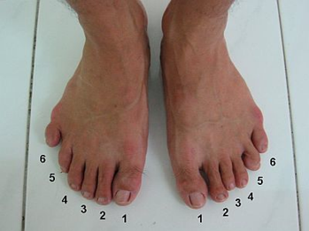
Polydactyly – having extra fingers or toes – is caused by a dominant allele (Use capital letter P to represent this) of a gene and can therefore be passed on by only one parent who has the disorder.

Research Task – Complete the table using the info above and your own research. Don’t forget, a good researcher does not get all their information from the opening lines shown in the search results. OPEN THE ARTICLES!!
Inherited disorder | Symptoms | Dominant or recessive | Possible genotypes of sufferer
Cystic fibrosis

Sickle cell anaemia |  |  | ss
Polydactyly |  | Dominant
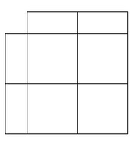
Draw the Punnett squares for this situation:
One parent is homozygous WITH polydactyly, the other doesn’t have the condition.

