NEW TOPIC – INHERITANCE
Inherited and environmental variation https://www.youtube.com/watch?v=jUHokSPkzT8
Look at your Mum/Dad/Carer/Brother/Sister. How are you different? How are you the same? The differences between animals of the same species are called variation. Some variation within a species is inherited a result of getting our genetic information from our parents.
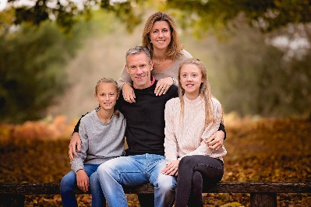
Children usually look a little like their father, and a little like their mother, but they will not be identical to either of their parents. This is because they get half of their DNA and inherited features from each parent. One example of an inherited characteristic is eye colour.

Characteristics of animal and plant species can be affected by their environment. For example weight, you will become heavier if you eat too much food, and you will become lighter if you eat too little. A plant in the shade of a big tree will grow taller as it tries to reach more light.
Variation caused by the surroundings is called environmental variation.
Some variation can be both inherited and due to environmental factors, for example skin colour. You can be born with pale skin but get a suntan.
Task 1 – Complete the following table, I have filled some in to get you started.
Characteristic | Inherited, environmental or both? | Explanation
Blood type | Inherited | You are born with a blood type, it is passed on in the genetic information from your parents
Tattoos |  | You cannot be born with a tattoo
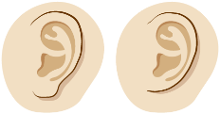
Lobed or unlobed ears

Hair colour

Weight

Height |  | Height is a characteristic than can be inherited but poor diet can affect your growth
Scars

Skin colour

Task 2- Apply your knowledge to complete the exam practice question
