YR 10: ART
Artist research sheet: Shepard Fairey
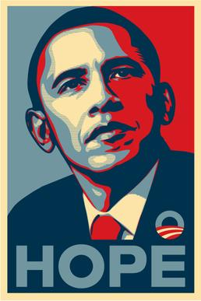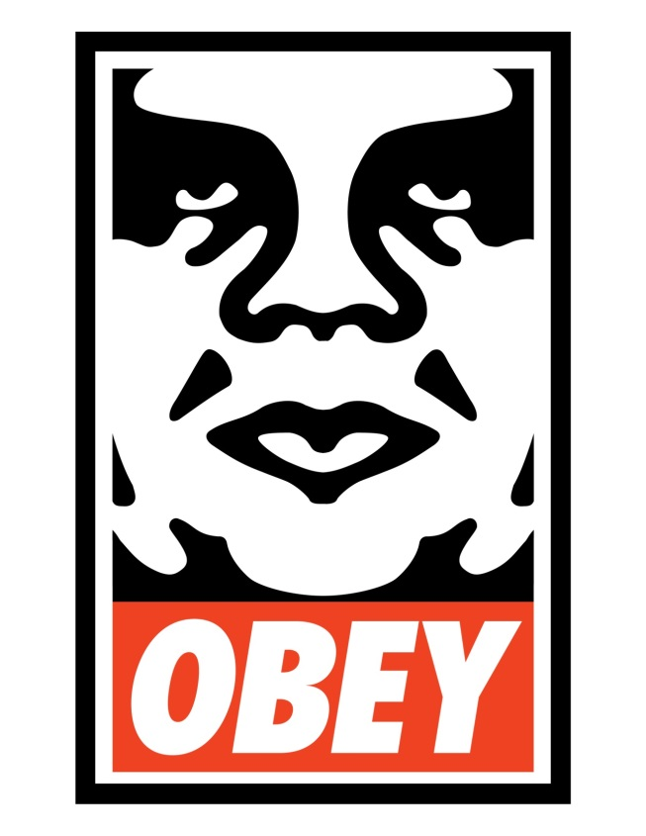
HOPE and OBEY by street artist Shepard Fairey.
- Research online relevant information about these two works. How did they come about? What was the process? What was the worldwide reaction?
- Discuss the political messages in Fairey’s work. How can art be used to deliver a political message?
- Write about the process of tracing, cutting and spraying your own versions of these two images. What went well? How could your work improve?
- Design and present a PowerPoint with your research findings!

