[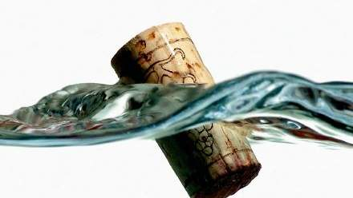](http://www.google.co.uk/url?sa=i&rct=j&q=&esrc=s&source=images&cd=&cad=rja&uact=8&ved=0ahUKEwjl2ZXWvofQAhVH1xQKHY6ZD40QjRwIBw&url=http://www.khaleejtimes.com/wknd/mindsport/cork-a-doodle-do&bvm=bv.137132246,d.ZGg&psig=AFQjCNH7G3G6KJ7Weq7aIU0DUKryQZ8Ghg&ust=1478087361499839)[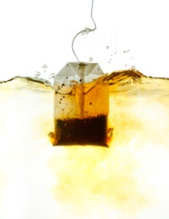](https://www.google.co.uk/url?sa=i&rct=j&q=&esrc=s&source=images&cd=&cad=rja&uact=8&ved=0ahUKEwjllLilvIfQAhWBWRQKHeKWCVIQjRwIBw&url=https://plus.maths.org/content/diffusion-plays-rules&bvm=bv.137132246,d.ZGg&psig=AFQjCNGy2xbBI509X2kR3MCysLk5UNaplA&ust=1478086724294774)[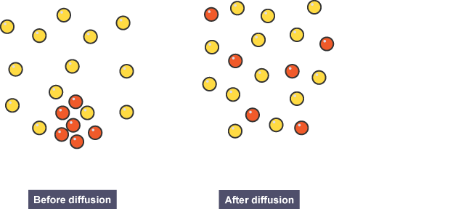](http://www.google.co.uk/url?sa=i&rct=j&q=&esrc=s&source=images&cd=&cad=rja&uact=8&ved=0ahUKEwjW1LjUu4fQAhVNnRQKHd2PAsYQjRwIBw&url=http://www.bbc.co.uk/education/guides/zc9q7ty/revision/8&bvm=bv.137132246,d.ZGg&psig=AFQjCNGdYWiXQj9Eioan3A4ech_ojqVhVg&ust=1478086537385881)[](http://www.google.co.uk/url?sa=i&rct=j&q=&esrc=s&source=images&cd=&cad=rja&uact=8&ved=0ahUKEwiPlfOOu4fQAhVEWRoKHQ1NAPAQjRwIBw&url=http://www.housebeautiful.com/room-decorating/colors/g558/front-door-color/&bvm=bv.137132246,d.ZGg&psig=AFQjCNFkQ8E2CVLaDeT0Zc6pjlNlznHNQA&ust=1478086407302140)[](https://www.google.co.uk/url?sa=i&rct=j&q=&esrc=s&source=images&cd=&cad=rja&uact=8&ved=0ahUKEwjIoKmAuYfQAhVCtxQKHXXqCs0QjRwIBw&url=https://sites.google.com/site/tria1andfai1ur3/over-analysis/oa-tv-shows/spongebob-decline-in-quality&psig=AFQjCNH684RqiAVQ1sS1ksC3B1OmP9y9Jw&ust=1478085702792743)

How could I work out the volume of this object?

Density =

Complete the table:

|  |  |  |
| --- | --- | --- |
| Mass (g) | Volume (cm3) | Density (g/cm3) |
| 5 | 10 |  |
| 20 | 200 |  |
| 10 |  | 5 |
|  | 100 | 10 |

7C1 – The

Particle Model

Explain why this cork floats in water

What factors could speed up diffusion? Consider how you can make this tea spread through water faster

Complete the diagram to show what the particles would look like after diffusion, write a definition of the key term and describe an example of it…

Challenge – Why does my front door get difficult to open on hot sunny days?

Challenge – A sponge is a solid so why can it be squashed?

Complete the following:

A solid has a fixed shape because…

A liquid can be poured because…

A gas fills any container because…

Heating a substance makes the particles…

Draw particle diagrams and label as many of the state changes as you can.

Gas

Liquid

Solid