NE Derbyshire Support Centre
Mathematics Department
Percentages Revision
- Find 10% of the following amounts

- £460
- 180g
- 36kg
- 24km

- For each of the amounts below find 5% and 20%

- £460
- 180g
- £28
- £8.20

- Calculate 15% and 25% of the values below

- £24
- 58km
- £76
- £3.60

- Calculate 1 % of

- 300g
- 320km
- £28
- £34

- Calculate (You will need a calculator for this part)
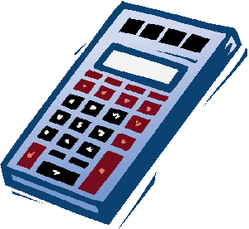
- 23% of 300g
- 19% of 320km
- 45% of £28
- 72% of £34

- Copy and complete the table
Fraction | Percentage | Decimal
1/2 | 50% | 0.5
1/4
 | 10%
 |  | 0.20
 | 5%
3/4

- The sweater shop is offering 20% discount on jumpers. If the regular price of a jumper is £15 what is the sale price?
- Pizzas normally cost £4.50 but the price has had to be increased by 15%. What is the new price?
- VAT is charged at a rate of 8% on gas. If your gas bill is £62 before VAT is added, what does it come to after VAT has been added?

