7B4L6
Toxins in Food Chains
Chemicals released from industrial waste can have serious effects on organisms in food chains. Once in their body, the toxin cannot be removed. This process is called bioaccumulation (or biomagnification). You are going to find out why…
- Toxins washed into rivers and lakes and was absorbed by plants called algae (al-gee). Put a dot in each algae to show that they have the chemical inside them.

- Mosquitoes eat algae. Each mosquito eats two algae plants every day. Put dots in the mosquito to show how much toxin they have taken in from eating algae.

- Small fish eat mosquitoes. Each small fish eats 10 mosquitoes every day. Put dots in the small fish to show how much toxin they have taken in from eating mosquitoes.

- Large fish eat small fish. Each large fish eats 3 small fish every day. Put dots in the large fish to show how much toxin they have taken in from eating small fish.

- Seals eat large fish. Each seal eats 2 large fish every day. Put dots in the seal to show how much toxin they have taken in from eating large fish.

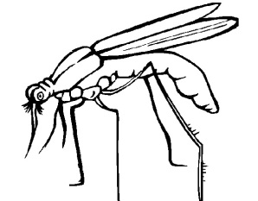

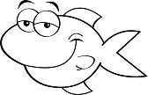

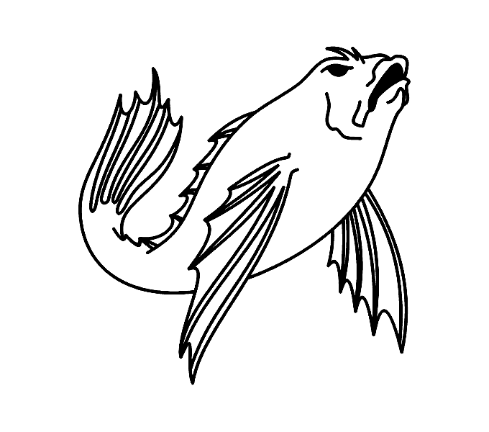

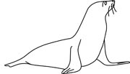

- This toxin is harmful when an animal has more than 100 doses in it. Which animals are going to be harmed by the chemical?
……………………………………………………………………………………………………………………………………
……………………………………………………………………………………………………………………………………
- People eat large fish. Should the government stop people from eating the large fish from this food chain? Explain your answer.
……………………………………………………………………………………………………………………………………
……………………………………………………………………………………………………………………………………
……………………………………………………………………………………………………………………………………
……………………………………………………………………………………………………………………………………
- Can you give two reasons why the dumping of chemical waste into landfills and water needs to be strictly controlled?
……………………………………………………………………………………………………………………………………
……………………………………………………………………………………………………………………………………
……………………………………………………………………………………………………………………………………
……………………………………………………………………………………………………………………………………
……………………………………………………………………………………………………………………………………
……………………………………………………………………………………………………………………………………
- Can you suggest some ways that this dumping of waste can be controlled
……………………………………………………………………………………………………………………………………
……………………………………………………………………………………………………………………………………
……………………………………………………………………………………………………………………………………
……………………………………………………………………………………………………………………………………
……………………………………………………………………………………………………………………………………

