**Local Governance 2023/24**

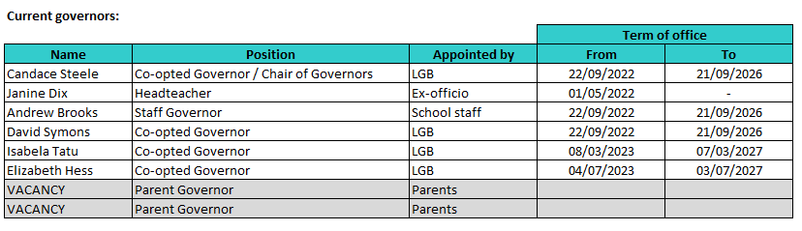

**Esteem Multi - Academy Trust - Governance Information and Declared Interests**

**Members, Trust Board, Accounting Officer and CFO- 2023/24**

|  |  |  |  |  |  |  |
| --- | --- | --- | --- | --- | --- | --- |
| **Esteem MAT Members** | | | | | | |
| **Name** | **Type** | | **Term** | | **Register of Interest** | **Chair / Vice Chair** |
| Bernadette Hunter | Member Appointed | | Appointed 07/06/2018 | | Previously Director /CEO/ AO at Central Cooperative Learning Trust and currently supporting | Chair |
| Ian Coker | Member Appointed | | Appointed 07/06/2018 | | Governor at Holbrook School for Autism |  |
| Katherine Soanes | Member Appointed | | Appointed 07/12/2022 | | Employee of National Governance Association (Esteem subscribes to the NGA)  Secretary for Oxton Community Fundraisers  Vice Chair Bishop Alexander Academy Governing Board (L.E.A.D MAT) |  |
| Gregory Longley | Member Appointed | | Appointed 30/06/2021 | | Related party employee of Esteem  Director at Beeply Ltd.  Director at Palatinate Venture Consulting LTD. |  |
| Mark Phillips | Member Appointed | | Appointed 12/07/2023 | | Chair of Governors at Castle Vale Nursery School  Director at MAPSF Business Support |  |
| Peter Hamer | Member Appointed | | Appointed 07/06/2018  Member until 08/12/2022 | | Director of TNC Ltd.  Governor at Holbrook School for Autism |  |
|  |  | |  | |  |  |
| **Esteem MAT Trust Board** | | | | | | |
| **Name** | **Type** | **Term** | | **Register of Interest** | | **Chair / Vice Chair** |
| Mark Emly | Co-opted | 07/06/2018 – 06/06/2026 | | Director – MRJF Consultancy Ltd Services Related party Director of Geneflow Ltd Governor at All Saints Primary School Trustee with Derby Diocesan Academy Trust (DDAT)  Director and Church Warden All Saints Church, Alrewas. | | Chair |
| Dawn Butler | Member Appointed | 07/06/2018 – 06/06/2026 | | Senior Manager at EMEA APAC at Molson Coors Beverage Company Limited Molson Coors Europe | | Vice Chair |
| Sheran Fernie | Co-opted | 23/09/2020 – 22/09/2024 | | Employed during year by Halsbury Travel Ltd. | |  |
| Craig Kennady | Member Appointed | 07/06/2018 – 06/06/2026 | | Current employment Inclusion North for NHS CCG Derbyshire / Expert Advisor Care and Treatment Review Hub / Current employment - A2E (Advocacy 2 Engagement) via Choice Support for and on behalf of the Care Quality Commission / Current employment - Relief Midday Supervisor at Crescent Primary School /Volunteer Sole Proprietor to Have Your Say Now which is a disability case work and advocate organisation / Company Director and Trustee to the charity AchieveAbility Ltd Commission Member to; Westminster Commission on Autism, Westminster AchieveAbility Commission on Dyslexia/Neurodiversity Co-Chair of the Derbyshire Autism Partnership / Chair of Chesterfield Medical Partnership Patient Participation Group(PPG) / Relief Midday Supervisor at Crescent Primary School from May 2013 Parent Governor at Spire Nursery and Infant School (TOO ends 25/09/2023) | |  |
| Jacqueline Bull | Co-opted | 05/10/2022 – 04/10/2026 | | Regional Director Duke of Edinburgh’s Award. | |  |
| Martin Finch | Co-opted | 05/10/2022 – 04/10/2026 | | Primary Director at Tapton School Academy Trust | |  |
| Pauline Melvin Anderson OBE | Co-opted | 18/10/2023 – 17/10/2027 | | Director at PMA Education Ltd  Director at Derby City Council (to Aug 23)  Director at The Traveller Movement  Director at Artcore Ltd | |  |
| Christopher Griffin | Member Appointed | 07/06/2018 – 31/08/2023 | | Assistant Headteacher, Foxford Community School, Coventry | |  |
|  |  |  | |  | |  |
| **Accounting Officer and CEO** | | | | | | |
| Julian Scholefield | Accounting Officer / Esteem CEO | N/A | | Trustee at Oasis Learning Community Director at National Autistic Society | | N/A |

|  |  |  |  |  |
| --- | --- | --- | --- | --- |
| **Chief Financial Officer** | | | | |
| David Nathan Smith | N/A | Appointed 09/01/2023 | None |  |